Assignment 2

1)

### **Shipping Addresses for October 2023 Orders**

**Business Problem:**  
Customer Service might need to verify addresses for orders placed or completed in October 2023. This helps ensure shipments are delivered correctly and prevents address-related issues.

**Fields to Retrieve:**

* ORDER_ID
* PARTY_ID (Customer ID)
* CUSTOMER_NAME (or FIRST_NAME / LAST_NAME)
* STREET_ADDRESS
* CITY
* STATE_PROVINCE
* POSTAL_CODE
* COUNTRY_CODE
* ORDER_STATUS
* ORDER_DATE

SELECT distinct oh.ORDER_ID, ol.PARTY_ID, p.FIRST_NAME, p.LAST_NAME, pa.ADDRESS1 as STREET_ADDRESS, pa.CITY,

pa.STATE_PROVINCE_GEO_ID as STATE_PROVINCE, pa.POSTAL_CODE, tn.COUNTRY_CODE,

oh.STATUS_ID as ORDER_STATUS, oh.ORDER_DATE

FROM order_header oh

join order_role ol on oh.ORDER_ID = ol.ORDER_ID

join person p on ol.PARTY_ID = p.PARTY_ID

join order_contact_mech ocm on oh.ORDER_ID = ocm.ORDER_ID

AND ocm.CONTACT_MECH_PURPOSE_TYPE_ID='SHIPPING_LOCATION'

join order_contact_mech as oc on oh.ORDER_ID = oc.ORDER_ID AND oc.CONTACT_MECH_PURPOSE_TYPE_ID = "PHONE_SHIPPING"

join telecom_number tn on oc.CONTACT_MECH_ID = tn.CONTACT_MECH_ID

join postal_address pa on ocm.CONTACT_MECH_ID = pa.CONTACT_MECH_ID

join order_status os on oh.ORDER_ID = os.ORDER_ID

where oh.order_type_id = 'SALES_ORDER'

AND oh.STATUS_ID IN ('ORDER_COMPLETED','ORDER_CREATED')

AND os.STATUS_DATETIME BETWEEN '2023-10-01 00:00:00' AND '2023-10-31 23:59:59';

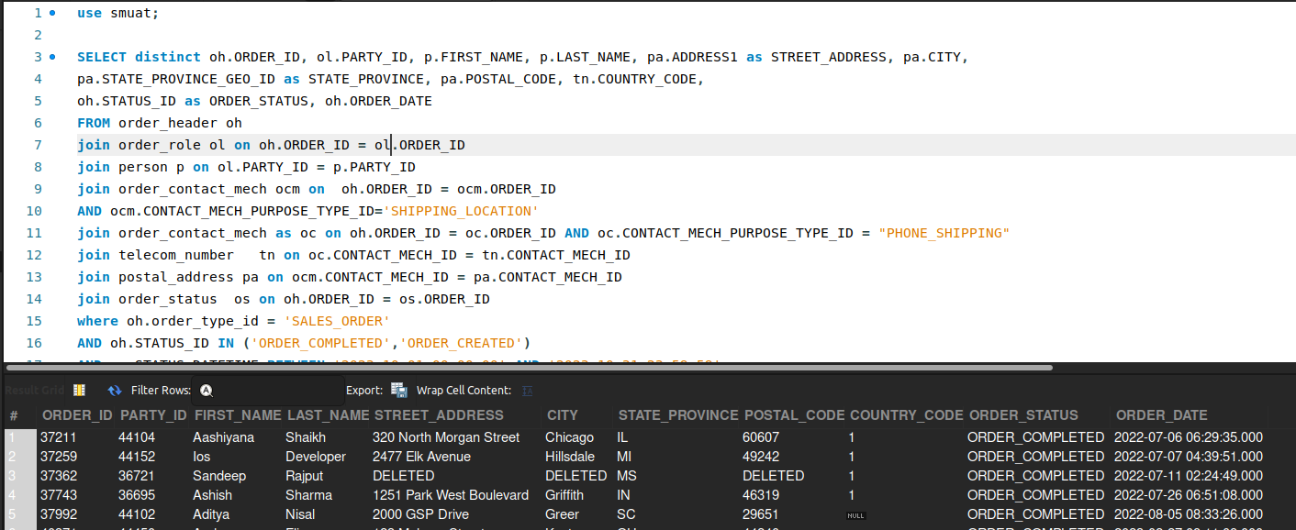

2)

### **Orders from New York**

**Business Problem:**  
Companies often want region-specific analysis to plan local marketing, staffing, or promotions in certain areas—here, specifically, New York.

**Fields to Retrieve:**

* ORDER_ID
* CUSTOMER_NAME
* STREET_ADDRESS (or shipping address detail)
* CITY
* STATE_PROVINCE
* POSTAL_CODE
* TOTAL_AMOUNT
* ORDER_DATE
* ORDER_STATUS

select distinct oh.ORDER_ID, p.FIRST_NAME, p.LAST_NAME,

pa.ADDRESS1 as STREET_ADDRESS, pa.CITY, pa.STATE_PROVINCE_GEO_ID as STATE_PROVINCE,

pa.POSTAL_CODE, oh.GRAND_TOTAL as TOTAL_AMOUNT, oh.ORDER_DATE, oh.STATUS_ID as ORDER_STATUS

from order_header oh

join order_role ol on ol.order_id=oh.order_id

join person p on p.PARTY_ID=ol.PARTY_ID

join order_contact_mech ocm on ocm.ORDER_ID=oh.ORDER_ID

join contact_mech cm on cm.CONTACT_MECH_ID=ocm.CONTACT_MECH_ID

join postal_address pa on pa.CONTACT_MECH_ID=ocm.CONTACT_MECH_ID

where pa.STATE_PROVINCE_GEO_ID='NY';

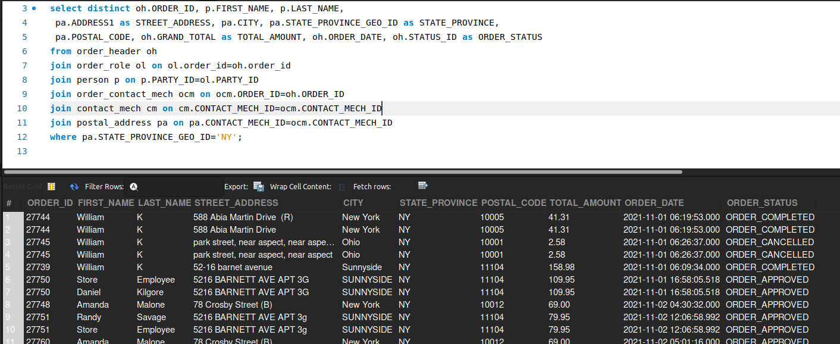

3)

### **Top-Selling Product in New York**

**Business Problem:**  
Merchandising teams need to identify the best-selling product(s) in a specific region (New York) for targeted restocking or promotions.

**Fields to Retrieve:**

* PRODUCT_ID
* INTERNAL_NAME
* TOTAL_QUANTITY_SOLD
* CITY / STATE (within New York region)
* REVENUE (optionally, total sales amount)

select p.product_id, p.internal_name, sum(oi.quantity) as TOTAL_QUANTITY_SOLD, pa.CITY, sum(oi.quantity * oi.unit_price) as REVENUE

from product p

join order_item oi on p.PRODUCT_ID = oi.PRODUCT_ID

join order_header oh on oh.ORDER_ID = oi.ORDER_ID

join order_contact_mech ocm on oi.ORDER_ID = ocm.ORDER_ID

join postal_address pa on ocm.CONTACT_MECH_ID = pa.CONTACT_MECH_ID

where pa.STATE_PROVINCE_GEO_ID = 'NY'

group by p.PRODUCT_ID, p.INTERNAL_NAME, pa.CITY

order by TOTAL_QUANTITY_SOLD desc

limit 1;

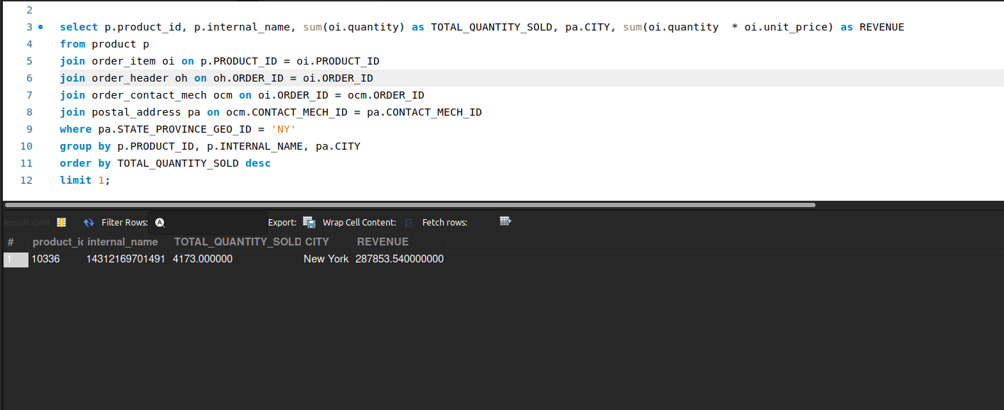

4)

### **Store-Specific (Facility-Wise) Revenue**

**Business Problem:**  
Different physical or online stores (facilities) may have varying levels of performance. The business wants to compare revenue across facilities for sales planning and budgeting.

**Fields to Retrieve:**

* FACILITY_ID
* FACILITY_NAME
* TOTAL_ORDERS
* TOTAL_REVENUE
* DATE_RANGE

select fa.FACILITY_ID, fa.FACILITY_NAME, count(oh.ORDER_ID) as TOTAL_ORDERS,sum(oh.GRAND_TOTAL) as TOTAL_REVENUE,

CONCAT(DATE(MIN(oh.ORDER_DATE)), ' to ', DATE(MAX(oh.ORDER_DATE))) AS DATE_RANGE

from facility fa

join order_header oh on oh.ORIGIN_FACILITY_ID=fa.FACILITY_ID

where oh.STATUS_ID='ORDER_COMPLETED'

group by fa.FACILITY_ID,fa.FACILITY_NAME

order by TOTAL_REVENUE desc;

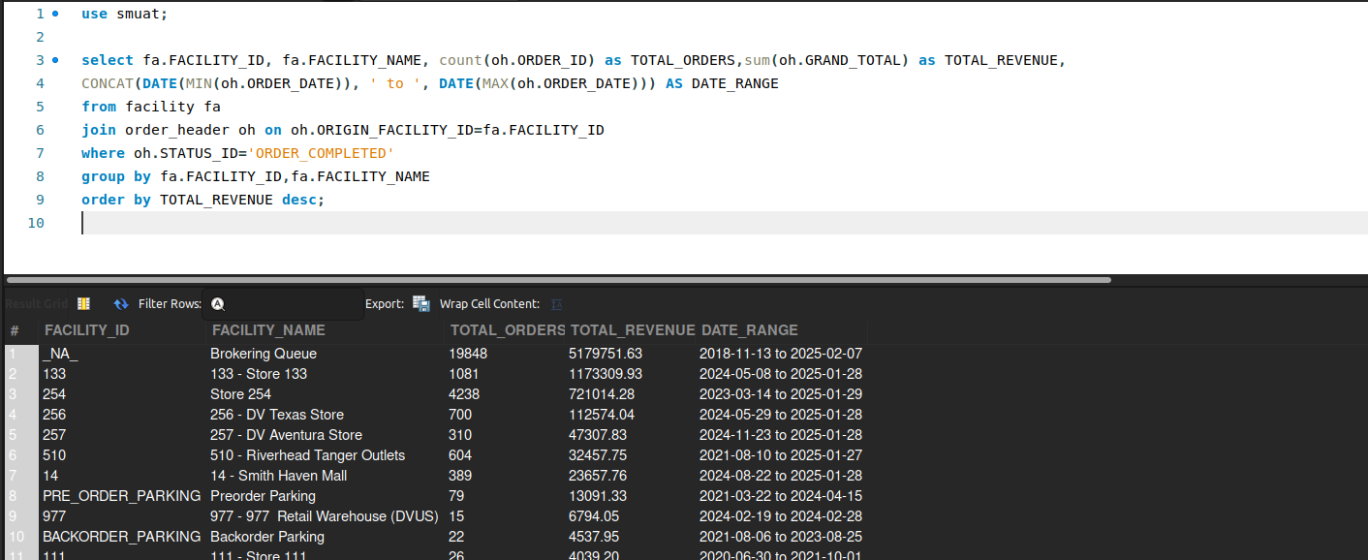

5)

### **Lost and Damaged Inventory**

**Business Problem:**  
Warehouse managers need to track “shrinkage” such as lost or damaged inventory to reconcile physical vs. system counts.

**Fields to Retrieve:**

* INVENTORY_ITEM_ID
* PRODUCT_ID
* FACILITY_ID
* QUANTITY_LOST_OR_DAMAGED
* REASON_CODE (Lost, Damaged, Expired, etc.)
* TRANSACTION_DATE

select ii.INVENTORY_ITEM_ID, ii.PRODUCT_ID, ii.FACILITY_ID, iiv.VARIANCE_REASON_ID as REASON_CODE,

iiv.QUANTITY_ON_HAND_VAR as QUANTITY_LOST_OR_DAMAGED, iiv.CREATED_STAMP as TRANSACTION_DATE

from inventory_item as ii

join inventory_item_variance iiv on ii.INVENTORY_ITEM_ID=iiv.INVENTORY_ITEM_ID and iiv.VARIANCE_REASON_ID in ('VAR_LOST','VAR_DAMAGED');

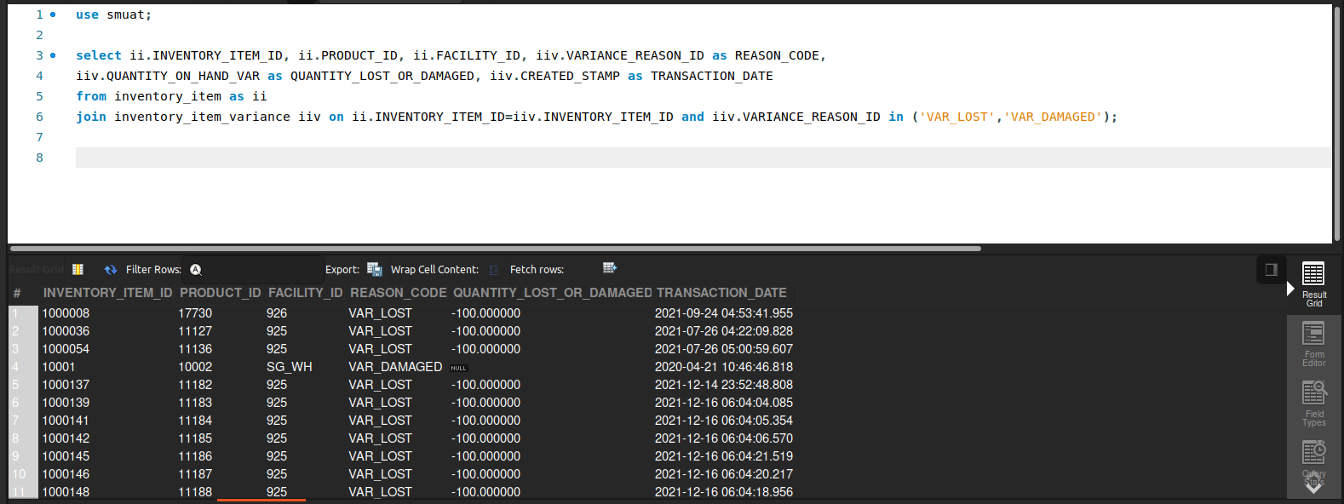

6)

### **Low Stock or Out of Stock Items Report**

**Business Problem:**  
Avoiding out-of-stock situations is critical. This report flags items that have fallen below a certain reorder threshold or have zero available stock.

**Fields to Retrieve:**

* PRODUCT_ID
* PRODUCT_NAME
* FACILITY_ID
* QOH (Quantity on Hand)
* ATP (Available to Promise)
* REORDER_THRESHOLD
* DATE_CHECKED

select p.PRODUCT_ID, p.PRODUCT_NAME, pf.FACILITY_ID, ii.QUANTITY_ON_HAND_TOTAL, ii.AVAILABLE_TO_PROMISE_TOTAL,

pf.MINIMUM_STOCK as REORDER_THRESHOLD, current_date() as DATE_CHECKED

from inventory_item ii

join product p on ii.product_id=p.product_id

join product_facility pf on pf.facility_id=ii.facility_id and p.product_id=pf.product_id

where ii.QUANTITY_ON_HAND_TOTAL<= pf.MINIMUM_STOCK;

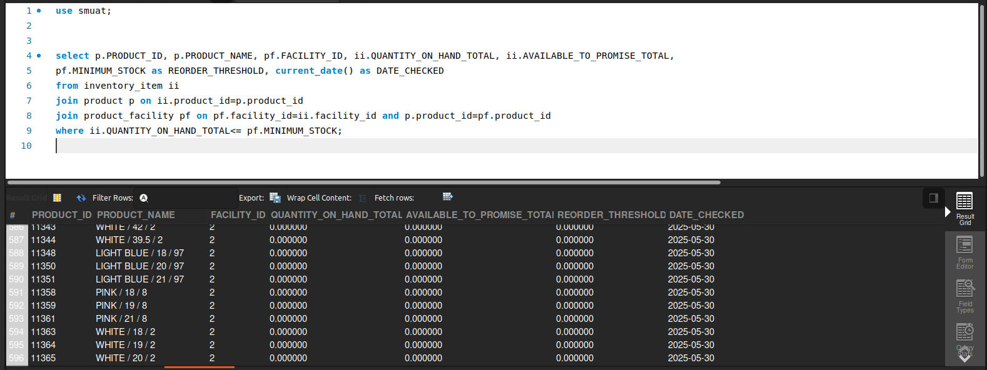

7)

### **Retrieve the Current Facility (Physical or Virtual) of Open Orders**

**Business Problem:**  
The business wants to know where open orders are currently assigned, whether in a physical store or a virtual facility (e.g., a distribution center or online fulfillment location).

**Fields to Retrieve:**

* ORDER_ID
* ORDER_STATUS
* FACILITY_ID
* FACILITY_NAME
* FACILITY_TYPE_ID

SELECT oh.ORDER_ID, oh.STATUS_ID as ORDER_STATUS, fa.FACILITY_ID,

fa.FACILITY_NAME, fa.FACILITY_TYPE_ID

FROM order_header oh

join order_item_ship_group oisg on oh.ORDER_ID = oisg.ORDER_ID

join facility fa on oisg.FACILITY_ID = fa.FACILITY_ID

where oh.STATUS_ID in ('ORDER_CREATED','ORDER_APPROVED');

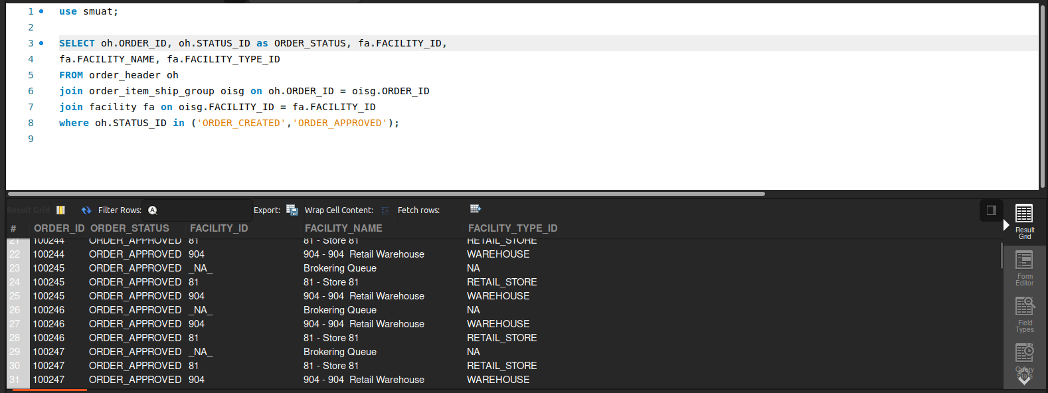

8)

### **Items Where QOH and ATP Differ**

**Business Problem:**  
Sometimes the **Quantity on Hand (QOH)** doesn’t match the **Available to Promise (ATP)** due to pending orders, reservations, or data discrepancies. This needs review for accurate fulfillment planning.

**Fields to Retrieve:**

* PRODUCT_ID
* FACILITY_ID
* QOH (Quantity on Hand)
* ATP (Available to Promise)
* DIFFERENCE (QOH - ATP)

select ii.PRODUCT_ID, ii.FACILITY_ID, ii.QUANTITY_ON_HAND_TOTAL, ii.AVAILABLE_TO_PROMISE_TOTAL,

(ii.QUANTITY_ON_HAND_TOTAL - ii.AVAILABLE_TO_PROMISE_TOTAL) as Diff

from inventory_item ii

where ii.QUANTITY_ON_HAND_TOTAL != ii.AVAILABLE_TO_PROMISE_TOTAL;

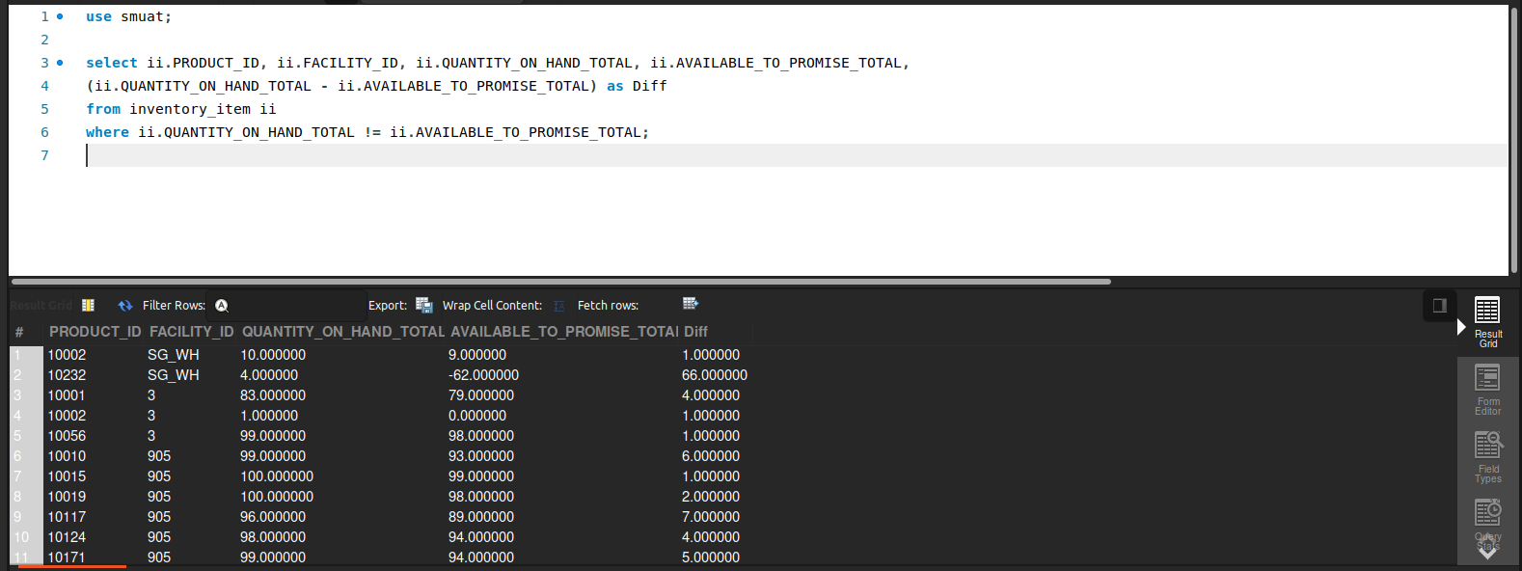

9)

### **Order Item Current Status Changed Date-Time**

**Business Problem:**  
Operations teams need to audit when an order item’s status (e.g., from “Pending” to “Shipped”) was last changed, for shipment tracking or dispute resolution.

**Fields to Retrieve:**

* ORDER_ID
* ORDER_ITEM_SEQ_ID
* CURRENT_STATUS_ID
* STATUS_CHANGE_DATETIME
* CHANGED_BY

select os.ORDER_ID, os.ORDER_ITEM_SEQ_ID,

os.status_id as CURRENT_STATUS_ID,

os.STATUS_DATETIME as STATUS_CHANGE_DATETIME,

os.STATUS_USER_LOGIN as CHANGE_BY

from order_status os

where os.ORDER_ITEM_SEQ_ID is not null;

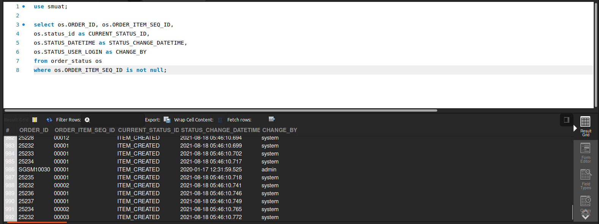

10)

### **Total Orders by Sales Channel**

**Business Problem:**  
Marketing and sales teams want to see how many orders come from each channel (e.g., web, mobile app, in-store POS, marketplace) to allocate resources effectively.

**Fields to Retrieve:**

* SALES_CHANNEL
* TOTAL_ORDERS
* TOTAL_REVENUE
* REPORTING_PERIOD

select oh.sales_channel_enum_id as SALES_CHANNEL,

count(oh.order_id) as TOTAL_ORDERS,

sum(oh.grand_total) as TOTAL_REVENUE,

DATE_FORMAT(oh.ORDER_DATE, '%Y-%m') AS REPORTING_PERIOD

from order_header oh

group by SALES_CHANNEL, REPORTING_PERIOD;

